Bahria University,

Karachi Campus

LAB EXPERIMENT NO.

**12**

LIST OF TASKS

|  |  |
| --- | --- |
| TASK NO | OBJECTIVE |
| 1 | **Create a database of a company which will hold employee info(_id,name,designation,salary,department) and department info(_id,name), insert 5 records on each table.** |
| 2 | **Increase employee salary to 10% if salary =10000** |
| 3 | **View all records updated** |
| 4 | **Delete records from department where department id is 5** |
|  |  |
|  |  |

Submitted On:

**4-July-2022**

**Task No 1: Create a database of a company which will hold employee info(_id,name,designation,salary,department) and department info(_id,name), insert 5 records on each table.**

**Solution:**

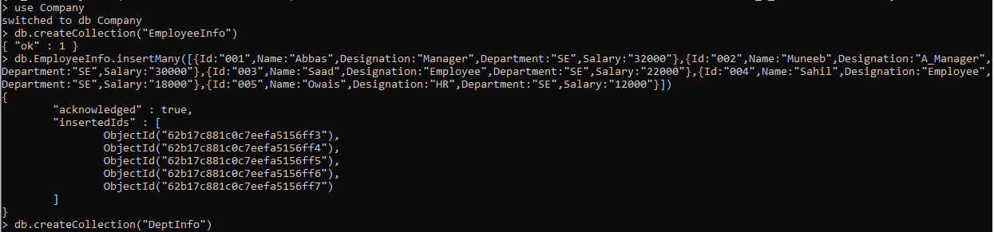

**Task No 2: Increase employee salary to 10% if salary =10000**

**Solution & Output**

**Task No 3: View all records updated**

**Solution & Output**

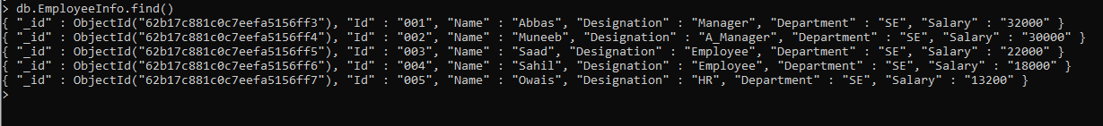

**Task No 4: Delete records from department where department id is 5**

**Solution & Output**

